Contents
Home Page 2
Store Page 4
Producers page 5
Customer Dashboard 6
Basket 7
About Page 9

Home Page
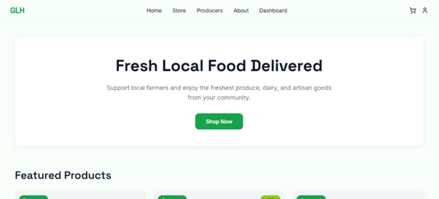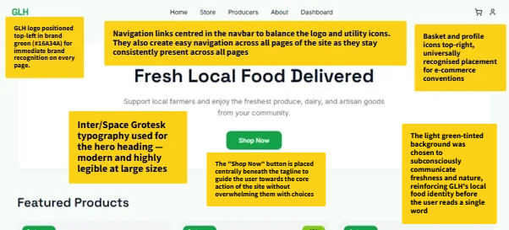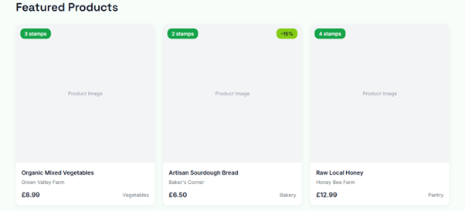
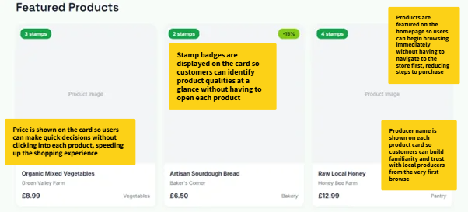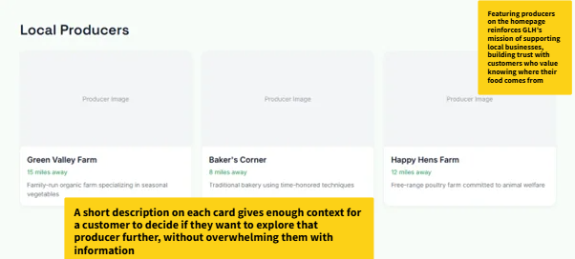
The homepage serves as the first point of contact for users visiting GLH. The navbar is fixed at the top with the GLH logo positioned top-left, as users naturally scan from left to right, ensuring immediate brand recognition. Navigation links are centred and always present across every page, reducing friction and allowing users to move freely through the site at any point in which they need. The basket and profile icons are positioned in the top-right, following established e-commerce conventions that users are already familiar with.

Store Page
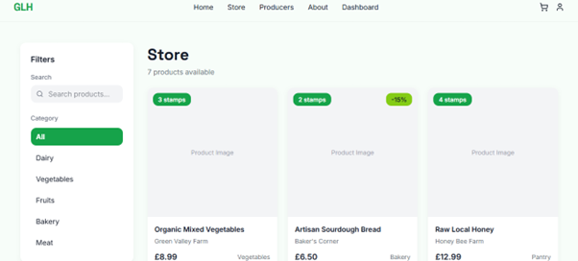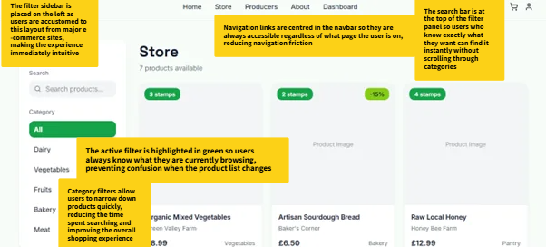

Producers page
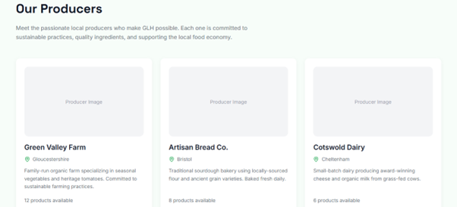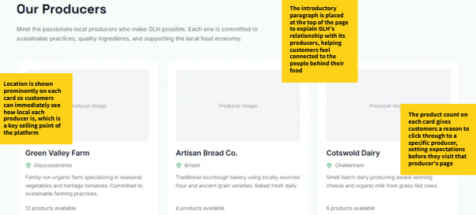
The producers page exists to strengthen the trust and connection between customers and GLH as a local food marketplace. An introductory paragraph sits at the top of the page explaining GLH's relationship with its producers, ensuring customers understand the values behind the platform before browsing individual businesses.

Customer Dashboard
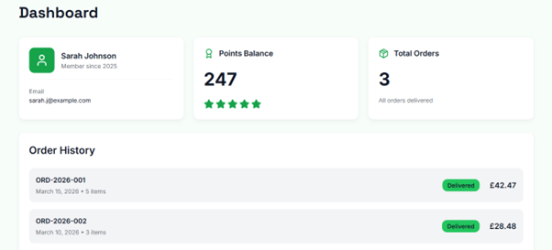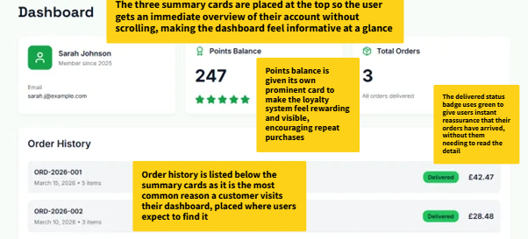
The customer dashboard is the personal hub of the GLH experience, designed to give users an immediate and clear overview of their accounts. Summary cards sit at the top of the page displaying profile information. The points balance is given its own card with star icons in brand green to make the loyalty system feel visible and rewarding, encouraging repeat purchases. Order history is listed directly below the summary, placed exactly where users expect to find it. Each order row displays the reference number, date, item count, delivery status and total price, giving users everything they need to review a past order immediately.

Basket
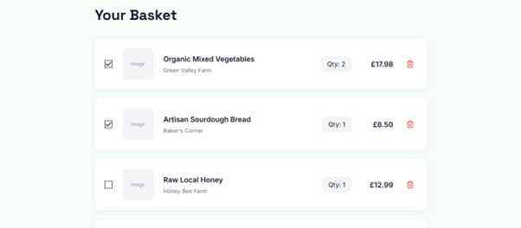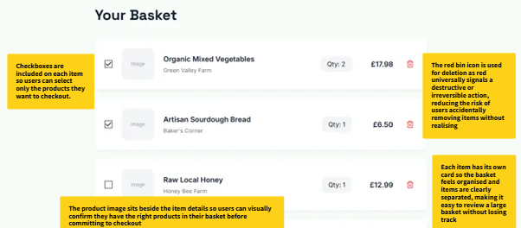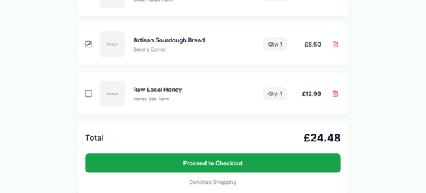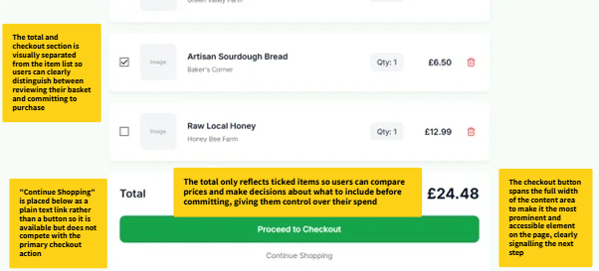

About Page
